PRODUCT NAME: **\*\*\*\*…………………………….**

INTRODUCTION:

PURPOSE:

TARGETAUDEINCE:

FUNCTIONAL & NON-FUNCTIONAL REQUIREMENTS OF HRMS

ADVANTAGES:

KEY FEATURES (FUNCTIONAL AND NON-FUNCTIONAL REQUIREMENTS):

**INTRODUCTION**

A Human Resource Management System (HRMS) is a software application that helps automate and manage various human resource processes, such as recruitment, on-boarding, employee data management, benefits administration, performance management, and compliance. HRMS systems can be integrated with other business systems, such as payroll and time and attendance, to provide a comprehensive solution for managing the entire employee lifecycle. The goal of an HRMS system is to streamline HR processes, improve data accuracy and accessibility, and increase efficiency and productivity.

The key purpose of an HRMS (Human Resource Management System) is to automate and streamline HR processes, such as tracking employee information, managing benefits and payroll, and handling recruitment and training. This allows HR departments to more efficiently and effectively manage their workforce, and can also provide valuable data and insights for strategic decision-making.

The main advantage of an HRMS (Human Resource Management System) is the ability to automate and streamline HR processes, such as recruiting, on-boarding, performance management, and benefits administration. This can help to improve efficiency and accuracy, reduce administrative burdens, and provide valuable insights into workforce data. Additionally, an HRMS can improve communication and collaboration among HR staff and employees, and can help to ensure compliance with legal and regulatory requirements.

HRMS (Human Resource Management System) helps companies manage their employee data, such as personal information, payroll, benefits, and performance evaluations. The current generation of HRMS systems often include features such as:

* Self-service portals for employees to access their own information and perform tasks such as requesting time off or updating their contact information.
* Mobile compatibility, allowing employees to access the system from their smartphones or tablets.
* Integration with other systems, such as payroll or benefits providers, to streamline data management and automate certain processes.
* Advanced reporting and analytics capabilities to help managers make data-driven decisions about staffing and workforce management.
* Cloud-based deployment options, which allow for easy access to the system from anywhere with an internet connection and eliminates the need for expensive on premise infrastructure.

**TARGET AUDIENCE**

************ is a software application that is used to manage and automate various HR-related tasks and processes. The target audience for ****** includes:

* **HR Professionals:** HRMS is primarily used by HR professionals and managers to manage various HR-related tasks and processes such as recruiting, hiring, onboarding, employee management, and performance tracking.
* **Business Owners and Managers**: Business owners and managers also use HRMS to manage their employees' data and access HR-related reports, to track employee performance, and to make informed business decisions.
* **Employees:** HRMS also allows employees to access their personal data, check their payroll, request leaves, and check their performance feedback, this can increase employee satisfaction and engagement.
* **Recruiters (Recruiting Agencies):** Recruiters use HRMS to manage job postings, review resumes and applications, and track the status of job candidates.
* **Payroll and Finance (Auditors):** HRMS can also be integrated with payroll and finance systems, allowing HR and finance professionals to manage employee data, payroll, and benefits more effectively.
* **IT Experts/consultants:** IT professionals use HRMS to manage the system and ensure that it is running smoothly and securely.

Overall, the target audience for an HRMS is diverse, covering a range of HR-related roles and functions within an organization, from HR professionals and managers to business owners, recruiters, employees and IT professionals.

**OVERALL DESCRIPTION OF HRMS**

The overall description of our HRMS can be stated as creating, running and managing the database, developing a friendly user interface to manipulate the database, provide an authentication mechanism to safely accomplish tasks mentioned above.

**HRMS PRODUCT PERSPECTIVE**

HRMS which is an online intranet System will be used by four types of employees. These types who have different roles can be stated as; admin, manager, HR, employee. Every user enters the main authentication page and after that, system will grant them authorization. After being authorized according to their permissions (role type) users will basically query and edit the database via HRMS.

***General use case diagram of HRMS* 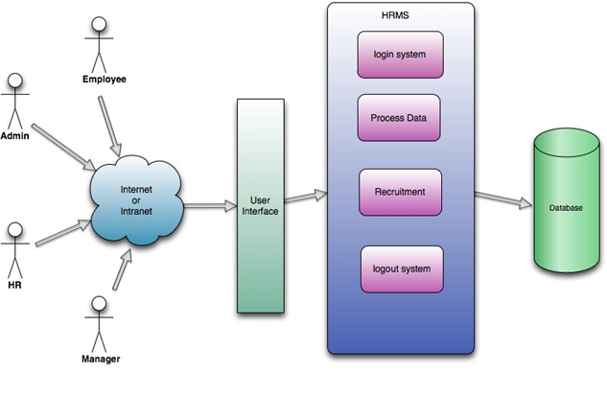**

**PURPOSE OF AN HRMS SYSTEM**

The purpose of a Human Resource Management System (HRMS) is to provide a centralized platform for managing and automating various HR-related tasks and processes. The main goal of an HRMS is to streamline HR processes, increase efficiency, and improve the overall management of an organization's human resources. An HRMS can be used for a variety of HR-related tasks and processes, including:

**Employee Management:** HRMS can be used to store and manage employee data, such as personal information, employment history, and job details.

**Recruiting and Hiring:** HRMS can be used to manage the recruiting and hiring process, including job postings, resume management, and applicant tracking.

**On boarding:** HRMS can be used to manage the onboarding process for new employees, including creating and distributing new hire paperwork, and tracking compliance with company policies.

**Performance Management:** HRMS can be used to track employee performance and provide feedback, including setting performance goals, tracking progress, and providing performance evaluations.

**Payroll and Benefits:** HRMS can be integrated with payroll and benefits systems, allowing HR professionals to manage employee data and payroll, and providing employees access to their pay and benefits information.

**Compliance:** HRMS can help ensure that an organization is in compliance with various labor laws and regulations, such as tracking employee hours and overtime, and maintaining accurate employee records.

**Reporting and Analytics**: HRMS provides reporting and analytics capabilities that allow organizations to access and analyze data on employee performance, turnover, and other HR-related metrics.

Overall, the purpose of an HRMS is to provide an efficient and effective way for organizations to manage and automate HR-related tasks and processes, allowing HR professionals to focus on strategic initiatives that drive business success.

**ADVANTAGES OF AN HRMS SYSTEMTop of Form**

1. **Improved efficiency:** An HRMS automates many of the tasks associated with human resources management, such as tracking employee information, managing benefits, and processing payroll. This can save time and reduce errors, leading to more efficient operations.
2. **Better data tracking and analysis:**

An HRMS can help organizations track and analyse data related to their human resources activities, such as employee turnover, performance, and compensation. This can help organizations identify trends and make data-driven decisions.

1. **Improved compliance:** An HRMS can help organizations ensure compliance with laws and regulations related to human resources management, such as those related to equal opportunity and employee benefits.
2. **Streamlined communication:** An HRMS can help employees and managers communicate more effectively, by providing them with a central location to access information and submit requests.
3. **Increased flexibility:** An HRMS can be configured to meet the specific needs of an organization, allowing for greater flexibility in terms of the types of data that can be tracked and the processes that can be automated.
4. **Cost savings:** An HRMS can help organizations save money by reducing administrative costs and improving the efficiency of their human resources activities.
5. **Better Talent management:** An HRMS can help organizations in recruiting, hiring, performance management, and succession planning, by giving them a central location to access and manage the data related to this activities.
6. **Employee Self-service:** An HRMS often provides employees with a self-service portal, where they can access and manage their personal information, request time off, and access company policies and benefits. This can reduce the workload of the HR department.

**KEY FEATURES OF HRMS**

HRMS (Human Resource Management System) is a software application that helps organizations manage their human resources functions. Some common features of HRMS systems include:

1. **Employee information management:** This feature allows HR professionals to store and manage employee information such as personal details, contact information, job titles, and employment history. This information can be easily accessed and updated as needed.
2. **Recruiting and onboarding:** HRMS systems often include tools for recruiting, such as job postings and applicant tracking. Once an employee is hired, HRMS systems can also assist with onboarding by providing new hires with necessary paperwork and tracking their progress through the onboarding process.
3. **Time and attendance tracking:** This feature allows HR professionals to track and manage employee time and attendance, including tracking of hours worked, vacation time, and sick leave.
4. **Benefits administration:** HRMS systems often include tools to help HR professionals manage employee benefits such as health insurance, retirement plans, and other perks offered by the company.
5. **Performance management:** Many HRMS systems include tools to help managers evaluate employee performance, track progress, and set goals.
6. **Training and development:** HRMS systems can provide managers with the ability to track employee training and development programs, and provide employees with the ability to access training materials and resources.
7. **Payroll and compensation management:** This feature allows HR professionals to manage employee payroll and compensation, including tracking of salaries, bonuses, and other forms of compensation.
8. **Compliance and reporting:** HRMS systems can help organizations stay compliant with various laws and regulations, such as tracking employee records and providing reporting capabilities for government agencies.
9. **Self-service portals for employees:** Self-service portals allow employees to access and update their personal information, view their paystubs and benefits information, request time off and manage other HR-related tasks.
10. **Mobile access:** Many HRMS systems are now mobile-friendly, allowing employees to access the system and perform certain tasks using their mobile devices.
11. **Communication and collaboration tools**: Some systems provide communication and collaboration tools, like company-wide announcements, employee suggestion box, employee directory, and others that helps the organization to improve communication and collaboration among employees.

**FUNCTIONAL FEATURES OF HRMS SYSTEM Top of Form**

1. **Employee Data Management:** This feature allows HR professionals to store and manage employee data such as personal details, contact information, job titles, and employment history. This information can be easily accessed and updated as needed.
2. **Recruitment and Hiring:** This feature allows HR professionals to manage the recruitment process, including job postings, resume screening, interview scheduling, and background checks. It also allows the HR professionals to manage the new hire paperwork and onboarding process.
3. **Time and Attendance**: This feature allows HR professionals to track and manage employee time and attendance, including tracking of hours worked, vacation time, and sick leave. It also allows the employees to submit timesheets and request for time off.
4. **Benefits Administration:** This feature allows HR professionals to manage employee benefits such as health insurance, retirement plans, and other perks offered by the company. It also allows employees to enrol in benefits, view their benefits information and make changes to their coverage.
5. **Performance Management:** This feature allows managers to evaluate employee performance, track progress, and set goals. It includes tools for goal setting, performance appraisals, and feedback.
6. **Learning Management:** This feature allows HR professionals to manage employee training and development programs, including tracking employee progress and providing employees with access to training materials and resources.
7. **Payroll and Compensation:** This feature allows HR professionals to manage employee payroll and compensation, including tracking of salaries, bonuses, and other forms of compensation. It also allows employees to view their paystubs and make changes to their direct deposit information.
8. **Compliance and Reporting:** This feature allows HR professionals to stay compliant with various laws and regulations, such as tracking employee records and providing reporting capabilities for government agencies. It also allows HR professionals to generate various reports such as headcount, turnover, and diversity.
9. **Self-Service:** This feature allows employees to access and update their personal information, view their paystubs and benefits information, request time off, and manage other HR-related tasks.
10. **Analytics and Business Intelligence:** This feature allows HR professionals to gain insights from the data stored in the system, such as employee turnover, headcount, and other key metrics. It also allows HR professionals to identify trends and patterns in the data that can be used to make informed decisions.
11. **Communication and Collaboration:** This feature allows HR professionals and employees to communicate and collaborate within the system. It includes tools such as company-wide announcements, employee suggestion box, and employee directory and discussion forums.

**NON-FUNCTIONAL FEATURES OF HRMS SYSTEM**

1. **Security:** This feature ensures that sensitive employee information is protected and only accessible to authorized users. It includes measures such as user authentication, data encryption, and access controls.
2. **Scalability:** This feature allows the HRMS system to grow and adapt as the organization's needs change. It ensures that the system can handle an increasing number of employees and transactions without performance degradation.
3. **Reliability:** This feature ensures that the HRMS system is available and functioning correctly at all times. It includes measures such as data backups, disaster recovery, and failover mechanisms.
4. **Usability:** This feature ensures that the HRMS system is easy to use for both HR professionals and employees. It includes features such as intuitive user interfaces, clear navigation, and easy-to-understand instructions.
5. **Interoperability:** This feature ensures that the HRMS system can integrate with other systems and applications within the organization. It allows HR data to be shared and exchanged between different systems, such as the payroll system and the time and attendance system.
6. **Accessibility:** This feature ensures that the HRMS system is accessible to all employees, including those with disabilities. It includes measures such as support for screen readers, keyboard navigation, and high contrast mode.
7. **Data Validation**: This feature ensures that the data entered into the HRMS system is accurate and complete. It includes validation rules and checks to ensure that only valid data is stored in the system.
8. **Data Backup and Recovery:** This feature ensures that the data stored in the HRMS system is safe and can be recovered in the event of a disaster or system failure. It includes regular data backups, disaster recovery procedures, and data restoration capabilities.
9. **Reporting and Analytics:** This feature provides the capability to generate various reports, including standard and custom reports, and also allows HR professionals to gain insights from the data stored in the system, such as employee turnover, headcount, and other key metrics.
10. **Mobile access and notifications**: This feature allows employees to access the system and perform certain tasks using their mobile devices and also allows them to receive notifications and updates related to the HRMS system.
11. **Integration with other systems:** This feature allows the HRMS system to integrate with other systems, such as payroll, time and attendance, and benefits, to share data and automate processes.

**HRMS USER EXPERIENCE**

User experience (UX) in the context of an HRMS (Human Resource Management System) refers to how easy, efficient, and satisfying it is for employees and HR staff to interact with and use the system. Some factors that can affect the UX of an HRMS include the system's navigation and layout, the ease of finding and accessing information, and the responsiveness of the system.

A good HRMS should have a user-friendly interface, be intuitive to navigate, and provide relevant information quickly and easily. Additionally, it should be easy for employees to perform tasks such as updating personal information, accessing benefits information, or submitting time-off requests. Overall, the user experience should make it easy for employees and HR staff to manage HR-related tasks and information effectively.

**The system architecture of an HRMS typically includes the following components:**

1. **Database:** This is the central repository for storing and managing all employee data, including personal information, job history, payroll, and benefits information.
2. **User interface:** This is the front-end of the system that allows users to interact with the system, such as by inputting data, running reports, and accessing information.
3. **Application server:** This component handles the processing of data and requests made by users. It also communicates with the database to retrieve and store data.
4. **Integration with other systems:** An HRMS may also integrate with other systems, such as a payroll system, time and attendance system, or benefits administration system.
5. **Security:** The system should be protected by security measures such as authentication, encryption, and access controls to ensure that only authorized users can access sensitive employee data.

### HRMS FUNCTIONS

HRMS implements some major functions in order to accomplish required tasks. These functions constitute a basis for the whole system. These functions can be stated as:

**Authentication and Authorization**

Being connected to internet, users will be able to get into the system. In order to see the interface related to his/her role type, the users account should be authorized and also his/her user name and password should be authenticated. These tasks are basically held by the functions implemented under the header of Authentication and Authorization major function.

**Process Data**

These functions which can be examined in that process data major function are basically provides user to manage the database according to the desired task. These management tasks constitute the major feature of the HRMS. With the help of these functions a user can update some basic personal data like contact information, marital status etc. In addition to update data, a user can also search the database in order to obtain the list of the users' which has the properties desired. Also a user may also see the specific information about a user or all users which can be named as report. In other words searching is the operation with rows of the database while reporting is operation with columns of the database.

**RECRUITMENT**

Recruitment of a new person which means introducing a new user to the system can be accomplished in two steps. When it is needed to add a new user to the system, firstly, HR must create an employee account, by the way at this step HRMS automatically gives an id to that user. At the second step, admin creates a user related to that user id.

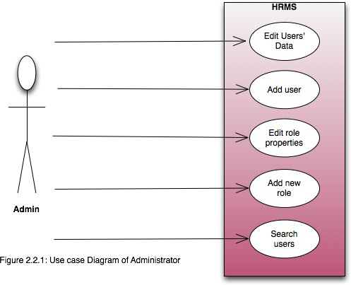

*User Case Diagram of Administrator*

*User Case Diagram of Employee*

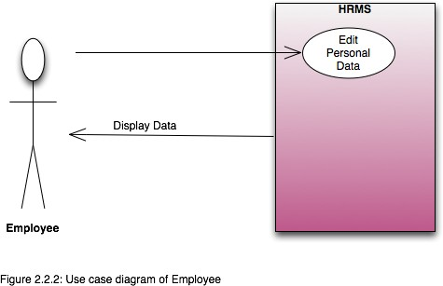

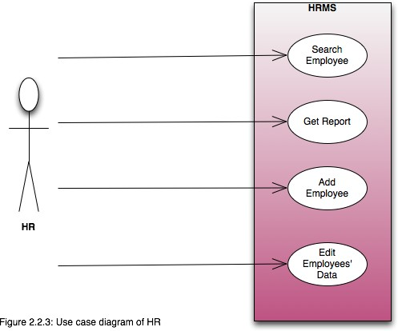

*User Case diagram of HR*

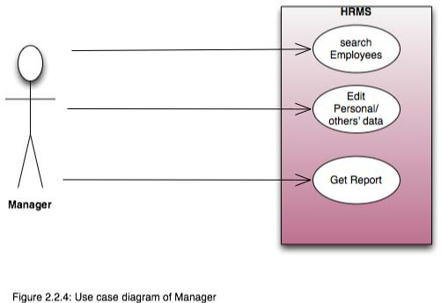

*User case Diagram of a Manager*

### CONSTRAINTS, ASSUMPTIONS AND DEPENDENCIES

#### Regularity Policies:

Each user must be an employee. In other words, each user has account created by HR and authenticated by admin.

#### Hardware Limitations

There is no limitation in the operating system in which HRMS will work. However, the HRMS system and the database will work on a server that needs to be always online. Users can access the system with any internet browser.

# SPECIFIC REQUIREMENTS OF HRMS

### Interface Requirements

All the users will see the same page when they enter HRMS. This page asks the users a username and a password.

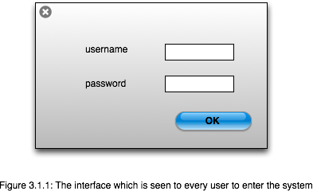

After being authenticated users will see the interface containing the information of the first tab of the user role types. This interface include different tabs according to their role types determined by admin at the authentication phase. By the way, users may have more than one role. Then a user who has more than one role will be able to see all the tabs that are related to his/her role types. These tabs can be named as; Personal Data Tab, Employee List Tab, Add New Employee Tab, Add New User Tab, Manage Users Tab, Users List Tab and Arrange Roles Tab.

User who have employee role have authorization to see only Personal Data Tab, HR role gives right to see Employee List Tab and Add New Employee Tab. Manager role gives authorization to see only Manager Tab. And Admin role gives user right to see User List Tab and Arrange Roles Tab.

These authorizations are default ones but an admin can change these authorizations by Arrange Roles Tab. These tabs can be explained detailed as:

**Personal Data Tab**

With the help of this tab, employees will be able to see their personal information which appears in a user-friendly design and also by means of this tab they may edit, update some information in other words manage some personal information which are updatable such as contact information, training information. This tab will only see by the users who has a role of Employee.

**Employee List Tab**

This tab gives the list of all employees as selectable format (there will be a check box near each employee). This tab includes two function buttons namely report and search.

When clicked on report button, a window will be opened which enables the user to select any column that he/she wants to see the specified employees’ (Employee list is selectable so HR can specify users by selecting them from the list) or all employees' information under preferred column/s.

When clicked on search button, again a window will be opened in which the user can enter the field name and the desired value. There can be more than one entry and user can choose to OR/AND them.

**Add New Employee Tab**

With this tab HR can add new employee (when a new employee is recruited) to the employee database with filling personal master data of this new employee. This tab adds new employee without any authenticated or authorized user attached to it. In other words only being added via this interface by HR is not enough to access this system. This account must be validated by admins.

Clicking on this tab an admin will see a window like:

**Add New User Tab**

With the help of his tab, Admins can add new user to the system. Admin can add user with user ID and arrange authentication and authorization to it. This user will be created by synchronized to the employee with the same ID from the employee database.

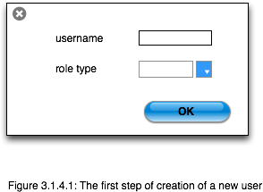

**Manager Tab**

With the use of this tab, Managers can edit information of employees who are attached to him/her. When this tab is selected there exist a search and report buttons (similar with the one in Employee List Tab but this one is restricted for employees whose manager is the user) and list of employees who are attached to him/her, below it. If Manager selects a user to display or edit information of, system displays information of that user in editable form.

**User List Tab**

In this tab, an Admin can list all users. Also there exist a search button as in Manage Users Tab which lets the admin to select user from the list by searching. After selecting the user, a new window is opened with information of that user. Admin can edit all information of that user including roles information (roles part of a user can be changed only by admin). When admin wants to change role of a user, a list came up of all roles determined in the system. Admin can select/deselect roles from this list; this selection determines authorization of this user. If any of these roles are selected then automatically this user becomes unauthenticated.

**Arrange Roles Tab**

In this tab, an Admin can list all roles determined in the system, display all users who have this role, arrange permissions for all roles and create new roles. In this tab, there are two lists and two buttons above them. These buttons are: “Change Permissions” and “Create New Role”, these two lists are Roles List above and Users List below. When Admin select any of the roles from the above list, all users who have that role are listed on the list below. From this list admin can not only displays users in that role but also change roles of these users.

### FUNCTIONAL REQUIREMENTS

In this section, we will explain the major functions of HRMS along with the data flow. So the major functionality of the project such as authentication mechanism, personal data processing, recruitment, report, and graphical user interface unit will be explained step by step.

**Authentication**

|  |  |
| --- | --- |
| Login | User can login to the HRMS system with his/her username and password. |
| Logout | User can logout from the HRMS system. |
| Login failure | If the user does not exist in the database or the user did not get authorized by the HRMS admin yet. |

**Authorization**

After logging in, the user role will be checked from the database and the user interface will be created according to that role/roles.

User role check

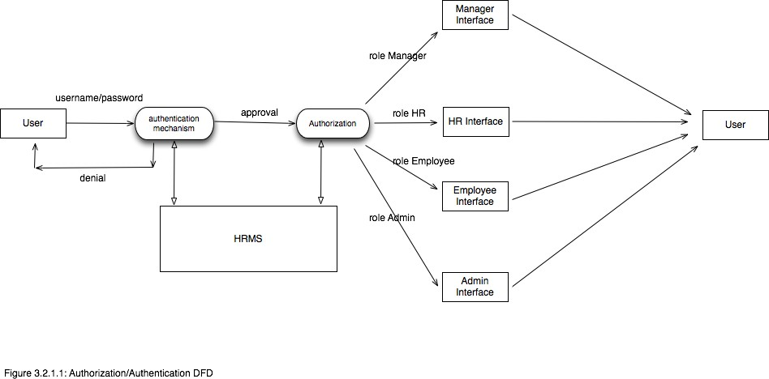

*Authorization/Authentication Diagram*

**Process Data**

|  |  |
| --- | --- |
| Display | User with defined roles can display the content of the database. Being more specific, employee can only view his/her personal information. Manager can see not only his/her personal information but also employees’ information who are working under his/her coverage.  Admin and HR can display their personal information and all employees’ information. |
| Edit | A user with employee role can edit his/her specific personal information. Manager can only edit employees’ personal information that is under his/her coverage except user role type. HR can edit all employees’ information except user role type. Admin can edit all information related to all employees’ including their user role type. |
| Search | User with manager role type can search the content of database for the employees who are under his/her coverage. HR and admin roles can search all the employees’ information in the database. Search feature works on specific keywords showing employees’ characteristics, peculiarities, skills, features, and etc. For example, HR wants to find employees who are well trained in “Java Programming Language”.  He/she will write the specific keyword in the search bar and press the available search button. Afterwards, he/she will find a list of all the employees’ who know “Java Programming Language”. |
| Report | This feature is basically used to filter the contents of the search mechanism. For instance, as we mentioned in the above search feature. The HR wants to get a report of some specific employees who know “java programming Language”. The list of employees obtained from the result of search feature he/she can get the specific report by selecting the corresponding checkbox available for each employee. Or a manager role type can get a report of some or all employees’ who are working under his/her coverage by selecting the checkbox. Except employee role type, all other role types such as admin, HR, and manager can use this feature. |
| Update authentication | This feature can be used only by admin role type. Admin can update the role type of a specific user. For example, an employee got promotion and his role type will be changed from employee role to manager role. Admin will be able to update this authentication mechanism. |

**Recruitment**

Add a new employee

HR role type is able to add a new employee to the database. The new employee will have all the required personal information related to his/her. The new created employee will have an id.

After being created a new employee by HR role, admin role is responsible for creating a new user by the specified id assigned in the “Add a new employee” feature. The unique id will be given by the system. Admin will assign a new role such as employee, manager, HR, and admin to the new created user.

Add a new user

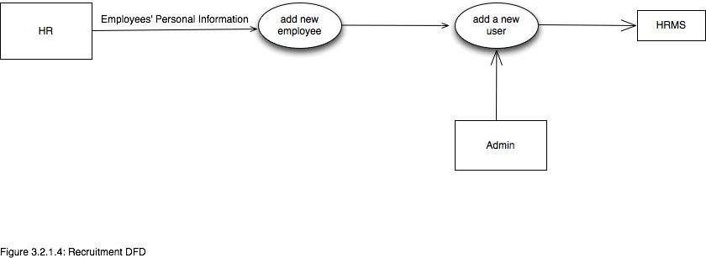

*Recruitment Diagram*

**NON-FUNCTIONAL REQUIREMENTS**

**Performance requirements**

* The number of the online user of the HRMS can be estimated as 50 at most.
* There is no restriction on the number of the users to be added to the database.
* Design constraints

**Hardware Requirements**

The HRMS application will be storing 200 employees’ personal data. Roughly … MB of storage capacity is needed.

**SOFTWARE REQUIREMENTS**

* Since HRMS application is a web-based application, internet connection must be established.
* The HRMS software will be used on PCs and will function via internet or intranet in any web browser.
* The HRMS application interface will be developed by Java (J2EE) frameworks
* The HRMS software will support JDK environment.
* The HRMS software personal database model will support MYSQL environment as DBMS.
* The HRMS will run on any platform supporting JDK technology.
* Application will run on 256MB or higher of RAM.

**Development Environment Requirements**

Eclipse IDE will be used for developing the HRMS web-based interface and its relation to person database module.

**Eclipse IDE**

Eclipse is a multi-language software development environment comprising an integrated development environment (IDE) and an extensible plug-in system. It is written mostly in Java and can be used to develop applications in Java and, by means of various plug-ins, other programming languages including Ada, C, C++, COBOL, Perl, PHP, Python, R, Ruby(including on Rails framework), Scala, Clojure, Groovy, and Scheme. It can be used to develop packages for the software Mathematica. The IDE is often called Eclipse JDT for Java programming language, Eclipse ADT (Ada Development Toolkit) for Ada, Eclipse CDT for C/C++, and Eclipse PDT for PHP. [5]

Eclipse is an open source community, whose projects are focused on building an open development platform comprised of extensible frameworks, tools and runtimes for building, deploying and managing software across the lifecycle. The Eclipse community is a not-for- profit, corporation who are members of the Eclipse community hosts the Eclipse projects and helps develop an open source community and a world of complementary products and services. [6]

MySQL Administrator or Microsoft SQL Server will be used to create, manage, and optimize the person database module.

**MySQL Administrator**

MySQL is a relational database management system (RDBMS) [7] that runs as a server providing multi-user access to a number of databases. The SQL phrase stands for Structured Query Language. [8]

The MySQL development platform has made its source code available under the terms of use of the GNU General Public License.

Open source free-software projects use MySQL if it is required a full-featured database management system. Several paid editions are available for commercial use, and offer additional functionality. MySQL is also used in may high-profile, large-scale World Wide Web products, including Wikipedia, Google, Facebook, and Twitter.

**Microsoft SQL Server**

Microsoft SQL Server is a relational database server, developed by Microsoft; it is a software product whose primary function is to store and retrieve data as requested by other software applications, be it those on the same computer or those running on another computer across a network (including the Internet). There are at least a dozen different editions of Microsoft SQL Server aimed at different audiences and for different workloads (ranging from small applications that store and retrieve data on the same computer, to millions of users and computers that access huge amounts of data from the Internet at the same time).[9]

**Data Model and Description**

This section describes attributes of database objects and relationship between them with a data table dictionary and tables to overcome confusions. These data objects are made under the consideration of getting rid of unnecessary attributes and normalization factors. The HRMS application consists of two main database groups. First one is storing information for Personal Master Data module and the second one is for Authorization and Authentication Module.

**Data Description of Personal Master Data Module**

In this section we mainly describe each table of the Personal Master Data Module in details. We determine each table and its responsibility in the module. Each table keeps many fields related to the specific data object. Then in the following sections we will explain the relationships of each database module table with each other.

* TBL_Employee
* TBL_APPL_User
* TBL_Employee_Projects
* TBL_Employee_TechnicalSkills
* TBL_Employee_Educatioin
* TBL_Employee_Languages
* TBL_Employee_Trainings
* TBL_Employee_Certificates
* TBL_Employee_Emergency_Call
* TBL_Employee_Quit
* TBL_Employee_Attachments

TO BE CONTINUED ……………………………………………..